Notes: These are two example results. Something to discuss…

Analysis

We compared the influence of insect orders, insect functional groups, and sampling location on alpha and beta diversity measures of aquatic insect microbiomes. To do this, we used intercept-only random effects models with the response variable as a measure of diversity (e.g., Bray-Curtis distance or Shannon’s entropy). Each model contained an intercept and three varying intercepts (insect order, functional group, and stream site).

There are several advantages to this modeling approach as described in Dietze (2017, pp. 92-93). First, by comparing the standard deviation of the varying intercepts, we can identify which variable is contributing the most to sample variation. The variables that contribute the most to sample variation are also the variables that are likely to be most profitable for explaining the insect microbiome in future investigations. Second, from these models, we can also predict the diversity of the microbiomes at each level (e.g., for each species or each stream or each functional group). Third, predictions at individual levels are less sensitive to outliers due to shrinkage as a result of partial pooling (Efron and Morris 1977). Fourth, the varying intercepts allow predictions, with proper uncertainty, of the microbiomes insects, sites or functional groups that are not currently in our dataset (McElreath 2020). Finally, the use of varying intercepts automatically adjusts for unbalanced data so that no single sample dominates the inference.

The “generalized” part of these models is through the choice of likelihood. In these models, we used either Beta or Gamma likelihoods, because the data were either restricted to the 0-1 range (e.g., Bray-Curtis) or were continuous and positive (e.g., Shannon’s entropy), respectively. This approach differs somewhat from the common approach of transforming data to fit assumptions of Gaussian likelihood (i.e., continuous values from negative to positive infinity). Because our data cannot take on values that are negative, rather than transforming them, we simply use a different likelihood with support for the data. The advantage of this approach is that the predictions of our model are on the scale of the measured outcome, such as Shannon’s entropy instead of log(Shannon’s entropy), and the model predictions are also not impacted by Jensen’s inequality.

The structure of each model is relatively simple, given by: TBD

We fit these models using Bayesian inference with Stan via *Brms*. Posteriors were explored with Hamiltonion Monte Carlo (No-U-Turn sampler). MORE…TBD.

Beta Diversity

Mean beta diversity (in units of Bray-Curtis distance) averaged ~0.7, ranging from ~0.6 at BIGC to 0.8 at BLDE (Figure 1a). There was similar variation among functional groups and insect orders (Figure 1a). As indicated by the standard deviations (Figure 1b), functional group contributes the most variation, followed by stream site and insect order. This indicates that future studies could focus more intensely on sampling more replicates of functional groups compared to more streams or insect orders. However, the overlap in distributions indicates that no single variable is clearly contributing the majority of variation (Figure 1b).

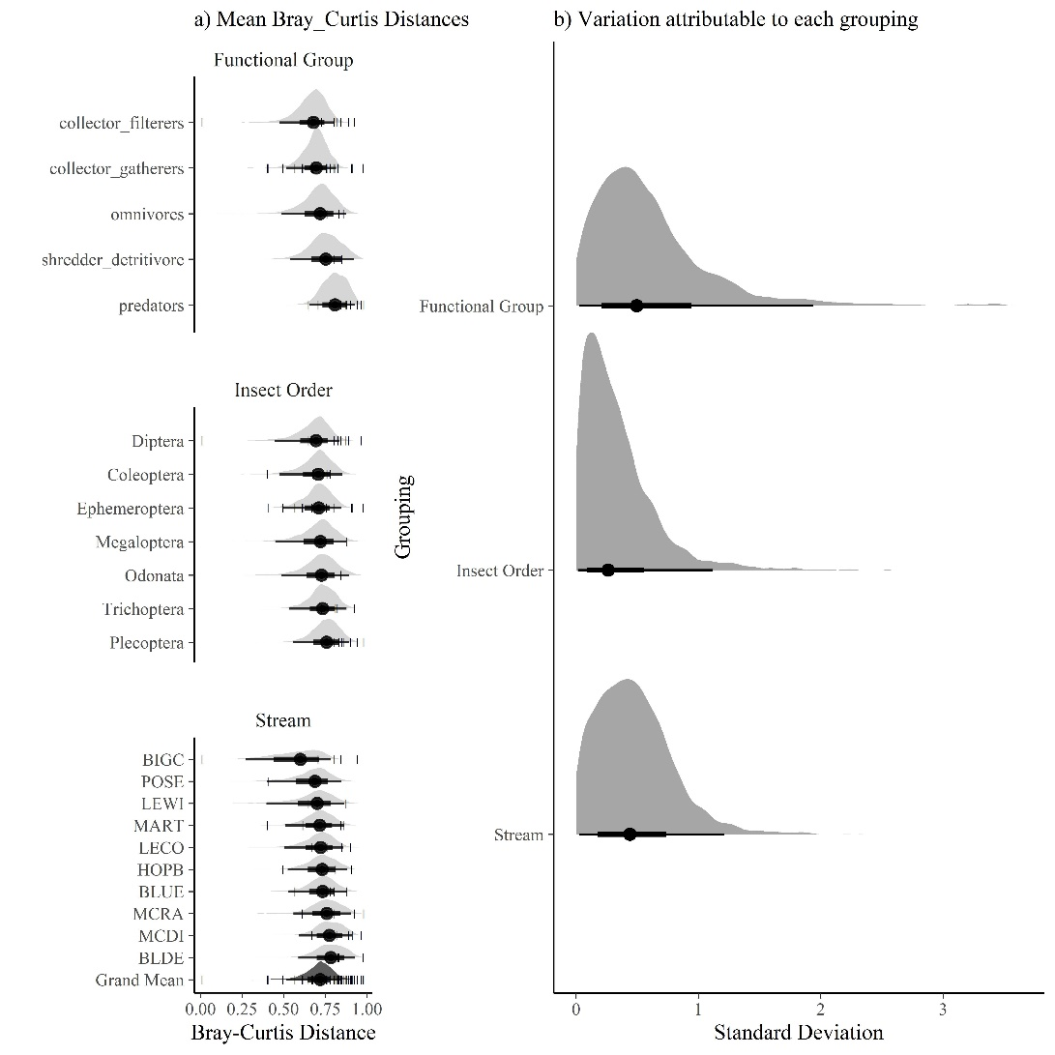

Figure 1. Model results for beta diversity as measured by Bray-Curtis Distances. a) Model predictions for mean Bray-Curtis distances. Light gray shows the posterior distributions of Bray-Curtis distances for each level of functional group, insect order, or stream. Dark gray shows the mean distance for the entire sample. In b) we attributed the variation in the entire sample (gray) to each of the three groupings (functional group, insect order, or stream).

Alpha Diversity

Mean alpha diversity (in units of Shannon’s Entropy) averaged ~3, ranging from ~2.5 at MCDI to ~5 at LEWI (Figure 2a). There was similar variation among functional groups and insect orders (Figure 2a). As indicated by the standard deviations (Figure 2b), functional group again contributes the most variation, followed by stream site and insect order. This indicates that future studies could focus more intensely on sampling more replicates of functional groups compared to more streams or insect orders. However, the overlap in distributions indicates that no single variable is clearly contributing the majority of variation (Figure 2b).

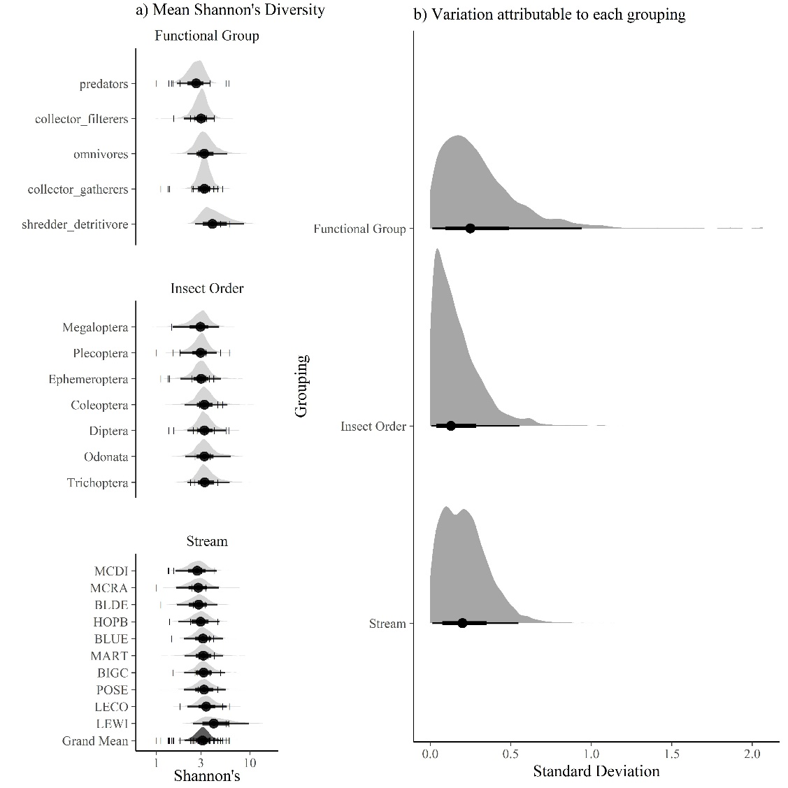

Figure 2. Model results for alpha diversity as measured by Shannon’s entropy. a) Model predictions for mean Shannon’s entropy. Light gray shows the posterior distributions for each level of functional group, insect order, or stream. Dark gray shows the mean entorpy for the entire sample. In b) we attributed the variation in the entire sample (gray) to each of the three groupings (functional group, insect order, or stream).